**ASSIGNMENT 29.1**

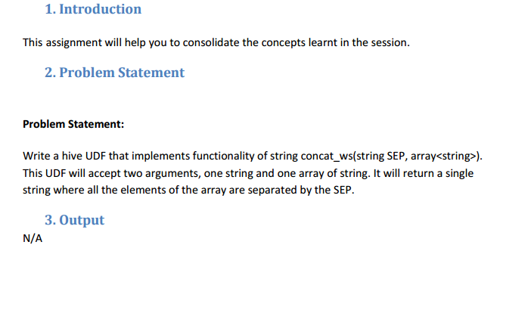Here is the java code to return all elements of the array separated by separator.

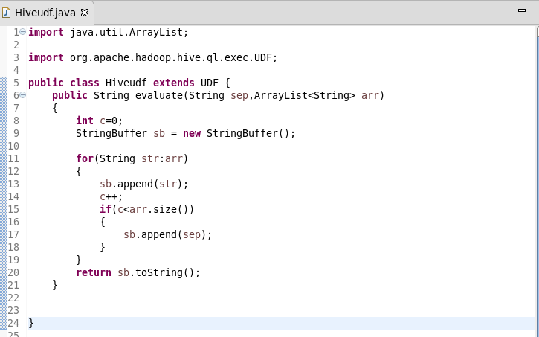

**Here, adding the jar file**

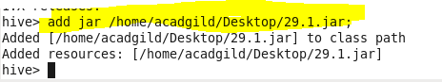

**Creating a table so as to perform operations using user define function and inserting data into it**

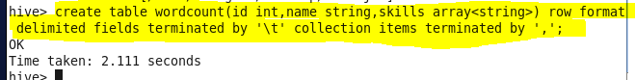

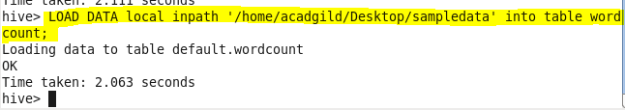

**Creating temporary function ‘tempfunc’**

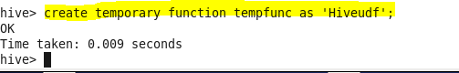

**Describing the table**

**Performing basic select operation.**

**Describe table we created for the given problem using desc and then using select all we can show the data in our table and retrieving data using temporary function we created**

